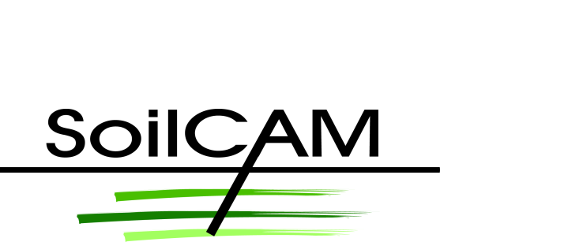All partners meeting
Location: Congress Center “Federico II”, Naples, Italy
Time |  | Activity | Responsible
September, 13th | 11:00 | WP leader meeting. Discuss progress, what should be dealt with by end of All partners meeting. Organisation of discussions on Tuesday. | Helen French
September, 13th | 13:00 | Lunch | Alfonso Filangieri
 | 14:00 | Welcome-introduction | Helen French
 | 14:30 | Financial issues | Hanne Sørlie
 | 15:00 | Status of the work: Completed work/delays, work flow and commitments | Helen French
 | 15:30 | Status of Work Worck packages, which information is required from other WPs? (20 min each)  WP1 Geophysical characterisation and monitoring  WP2 Bio-geo chemical characterisation and monitoring  WP3 Flow and transport modelling | Laust Pedersen,  Markus Wehrer, Sjoerd vder Zee,
 | 16:30 | Coffee break
 | 17:00 | WP4 New technologies  WP5 Monitoring sustainable remediation  WP6 Integrated strategies | Alberto Godio,  Guido Greco, Sjoerd vder Zee
 | 19:00 | Dinner
September, 14th | 9:00 | Introduction group discussions based on presentations Monday | Helen French
 | 9:30 | Group discussions, clarify issues – communicate details about results and how to integrate  Geophysical and data-bio-geo chemical data integration  *How to solve issue of combining datasets representative of different scales and uncertainty such as hydrogeological parameters and geophysical maps.  *Geophysical signatures produced by bio-geochemical activity, measureable or not?  Modelling, integration of soil characteristics – tool for producing situations to be analysed by geophysical methods – synthetic datasets | Responsible persons and topics for group discussions decided during WP leader meeting on Monday morning
 | 13:00 | Lunch
 | 14:00 | Group discussions, cont, same topics as above: | Same as above
 | 15:00 | Presentation of groups work, plans for continuation  AB members – comments
 | 16:00 | Coffee break
 | 16:30 | GIS – data storage sharing | Paul A. Aakerøy
 | 17:00 | Dissemination: Publication plan | Sjoerd vder Zee
 | 19:30 | Dinner - Social event* | Alfonso Filangieri
September 15th | 9:00 | Model Probe – progress and collaboration | (Matthias Kästner, - not attending)
 | 10:00 | EU perspectives | Panos Balabanis – not confirmed  (Scientific officer)
 | 10:20 | Dissemination towards end-users –opportunities for showing off what we do, stakeholder involvement, EU policy makers. | Helen French
 | 11:00 | Coffee break
 | 11:30 | View through the project: is it clear what we are going to arrive at end of project? | Helen French  WP leaders
 | 13:00 | Lunch
 | 14:00 | End of meeting? Or more topics to be discussed?

Home work in preparation for meeting:
WP leaders: What is status of your WP? Is the work sufficiently integrated with other WPs and are partners taking responsibilities for their contributions? Follow up from comments from AB during last All partners meeting.
All partners: Is all clear concerning the Deliverables you are the main responsible partner for (check p. 29 in DOW, B1.3.4 Deliverables list – Lead beneficiary). If you have specific questions to partners in other WPs regarding how different data sets should be interpreted and combined please put these forward to the relevant partner with copy to entire SoilCAM group: soilcam@bioforsk.no so the required data can be made available at the meeting.
The Advisory Board will be welcome to contribute with comments and questions throughout the meeting.

